**Year 12 Examination, 2019**

**Question/Answer Booklet**

**MATHEMATICS SPECIALIST**

**Section Two: Calculator-assumed**

Student Name/Number: ______________________________________________

Teacher Name: ______________________________________________

**Time allowed for this section**

Reading time before commencing work: ten minutes

Working time for this section: one hundred minutes

**Materials required/recommended for this section**

**To be provided by the supervisor:** This Question/Answer Booklet

Formula Sheet (retained from Section One)

**To be provided by the candidate:**

Standard items: pens (blue/black preferred), pencils (including coloured), sharpener, correction fluid/tape, eraser, ruler, highlighters

Special items: drawing instruments, templates, notes on two unfolded sheets of A4 paper, and up to three calculators approved for use in the WACE examinations

**Important note to candidates**

No other items may be taken into the examination room. It is **your** responsibility to ensure that you do not have any unauthorised notes or other items of a non-personal nature in the examination room. If you have any unauthorised material with you, hand it to the supervisor **before** reading any further.

**Structure of this paper**

|  |  |  |  |  |  |
| --- | --- | --- | --- | --- | --- |
| Section | Number of questions available | Number of questions to be answered | Working time (minutes) | Marks available | Percentage of exam |
| Section One: Calculator-free | 8 | 8 | 50 | 54 | 35 |
| Section Two: Calculator-assumed | 13 | 13 | 100 | 100 | 65 |
|  | | | | | 100 |

**Instructions to candidates**

1. The rules for the conduct of School exams are detailed in the *_______________________________________School/College assessment policy*. Sitting this examination implies that you agree to abide by these rules.
2. Write your answers in this Question/Answer booklet preferably using a blue/black pen. Do not use erasable or gel pens.
3. You must be careful to confine your answer to the specific question asked and to follow any instructions that are specified to a particular question.
4. Show all your working clearly. Your working should be in sufficient detail to allow your answers to be checked readily and for marks to be awarded for reasoning. Incorrect answers given without supporting reasoning cannot be allocated any marks. For any question or part question worth more than two marks, valid working or justification is required to receive full marks. If you repeat any question, ensure that you cancel the answer you do not wish to have marked.
5. It is recommended that you do not use pencil, except in diagrams.
6. Supplementary pages for planning/continuing your answers to questions are provided at the end of this Question/Answer booklet. If you use these pages to continue an answer, indicate at the original answer where the answer is continued, i.e. give the page number.
7. The Formula sheet is not to be handed in with your Question/Answer booklet.

**Section Two: Calculator-assumed 65% (100 Marks)**

This section has **13** questions. Answer **all** questions. Write your answers in the spaces provided.

Supplementary pages for planning/continuing your answers to questions are provided at the end of this Question/Answer booklet. If you use these pages to continue an answer, indicate at the original answer where the answer is continued, i.e. give the page number.

Working time: **100 minutes.**

**Question 9 (4 marks)**

A set of solar panels generate electric power during the day.

The table below shows how much power is generated every two hours during one particular day.

|  |  |  |  |  |  |  |  |
| --- | --- | --- | --- | --- | --- | --- | --- |
| Time (hours after midnight) | 7 | 9 | 11 | 13 | 15 | 17 | 19 |
| Electric power generated (kW) | 0.24 | 1.57 | 2.87 | 3.15 | 2.77 | 1.53 | 0.16 |

Use the trapezoidal rule to estimate the total amount of electricity generated (in kilowatt-hours) during the twelve-hour period.

**Question 10 (6 marks)**

(a) Complete the table: (2 marks)

|  |  |
| --- | --- |
|  |  |
| Vertical asymptote at | *x-*intercept at |
| Horizontal asymptote at | Horizontal asymptote at |

(b) The graph of a function is sketched below.

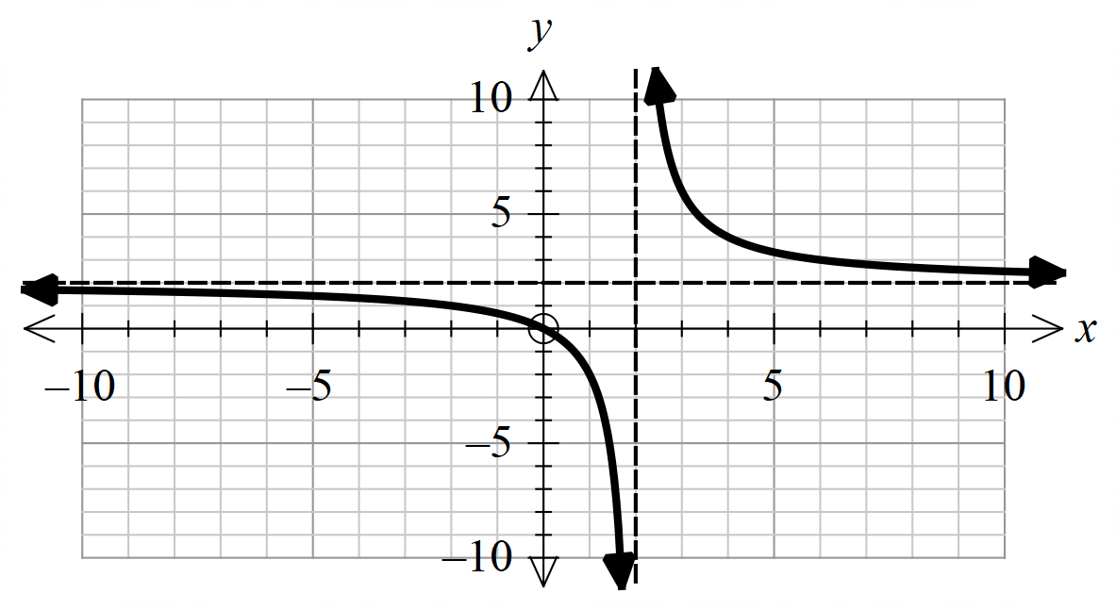

Use this to sketch the graphs of

1.  (2 marks)

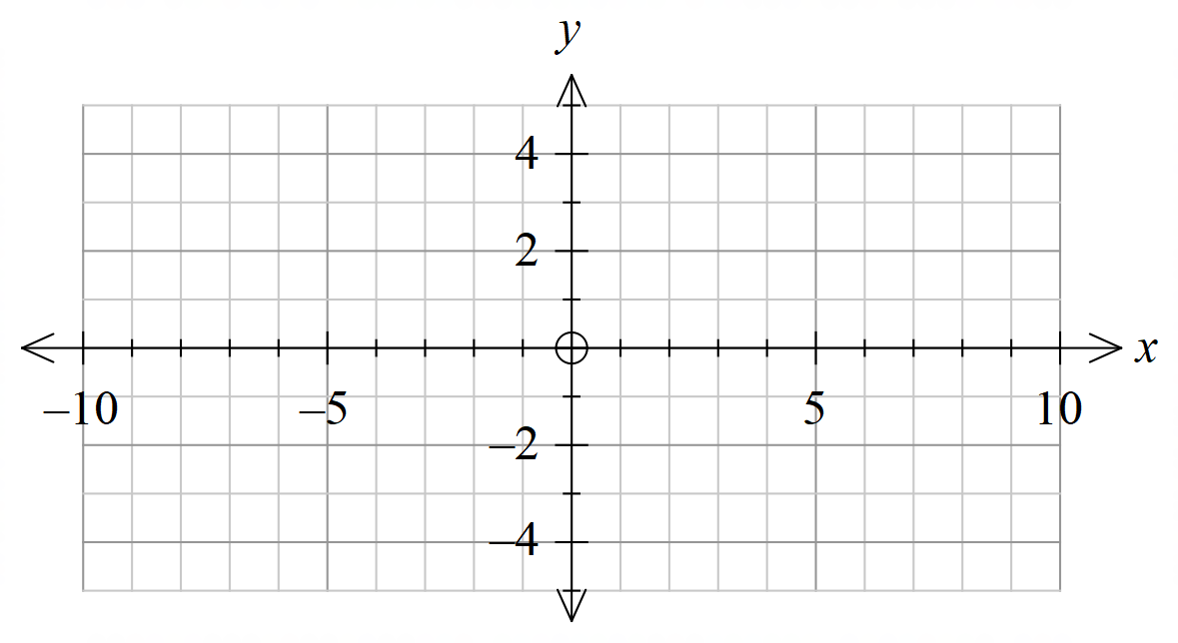

1.  (2 marks)

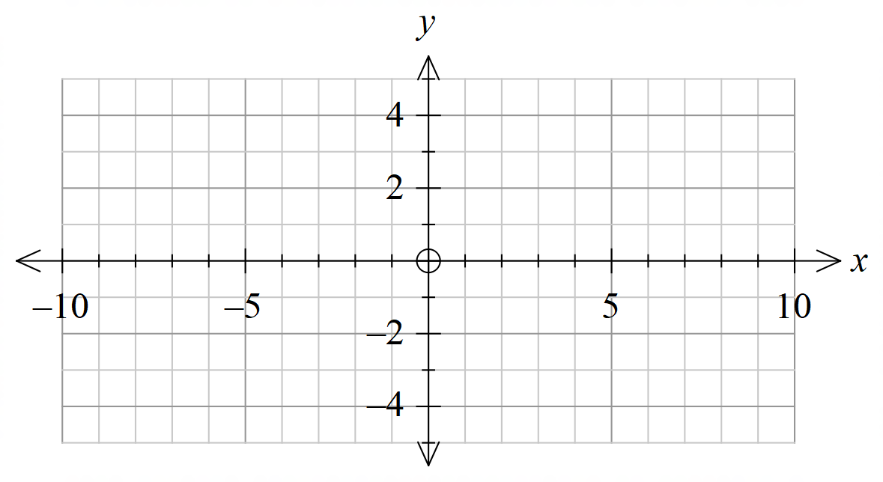

**Question 11 (5 marks)**

Functions *f* and *g* are defined such that:





The diagram below shows the graph of .

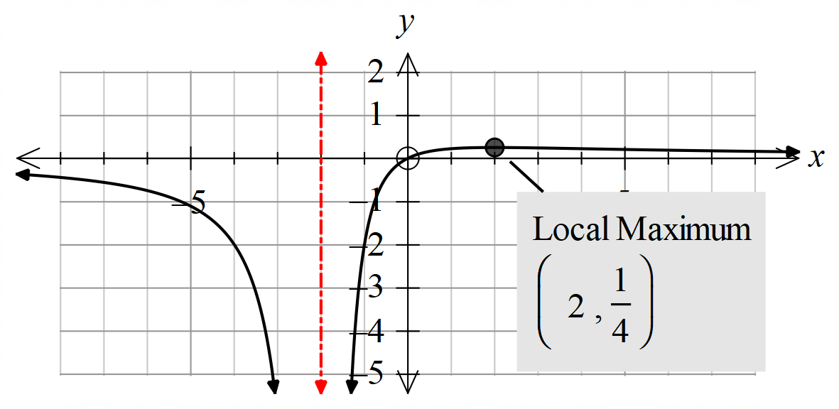

(a) Explain why the inverse function,  does not exist. (1 mark)

(b) State why the composite function exists. (2 marks)

(c) Determine . (1 mark)

(d) Hence, determine the range of . (1 mark)

**Question 12 (5 marks)**

(a) Determine the general solution of the differential equation

. (3 marks)

(b) Show that the solution curve passing through (1,0) is a circle. State its radius and centre. (2 marks)

**Question 13 (8 marks)**

(a) Given that , show that

 . (3 marks)

(b) The acceleration, *a* ms-2 of a body moving in a straight line in terms of the velocity, *v* ms-1 is given by . The displacement of the body is  metres.

If the displacement  when , determine the velocity of the body when .

(5 marks)

**Question 14 (6 marks)**

1. Determine all the roots of  expressing you answers in polar form with argument in the range . (3 marks)

1. Hence, or otherwise, determine the roots of (3 marks)

.

(Leave your answers in any convenient form.)

**Question 15 (9 marks)**

In this question $\overline{X}$ denotes the mean of a random sample of size $n$ taken from a population S of real numbers. The mean and variance of the numbers in S are $0.5$ and $1/12$ respectively.

(a) Write down the mean and variance of the sample $\overline{X}$ assuming that $n=2.$ (2 marks)

(b) Evaluate $P,$ the probability that $\overline{X}≤0.25,$ given that the numbers in S are normally distributed and $n=2.$ (2 marks)

In parts (c) and (d) of this question we may assume that the numbers in S are uniformly distributed between the limits $0$ and $1.$ The mean and variance are $0.5$ and $1/12$, respectively.

Choosing a random sample of size $2$ from S is essentially the same as randomly picking a point in the unit square and noting its coordinates.

$0$

$0$ $0.5$ $1$

$x+y=0.5$

(c) Evaluate $P,$ the probability that $\overline{X}≤0.25,$ given that $n=2.$ (2 marks)

(d) Estimate $P,$ given that $n=10.$ (3 marks)

**Question 16 (9 marks)**

1. Use the substitution to evaluate (2 marks)





1. If is a function defined on the interval , use the substitution  to prove that

. (2 marks)

1. Evaluate the integral (5 marks)





**Question 17 (7 marks)**

1. Determine the real numbers and  if (4 marks)



is such that .

1. With these values of and , express as a product of quadratic factors.

(3 marks)



**Question 18 (7 marks)**

In a very large study conducted 10 years ago it was discovered that the number of hours of TV watched by children in a certain age bracket was normally distributed, with mean $15.7$ and standard deviation $3.4$.

Social scientists now wish to discover whether the viewing habits of children of that age have changed. They will do this by measuring the number of hours of TV viewed by children in a random sample, and constructing a confidence interval for the new mean.

It is reasonable to assume that the standard deviation of viewing times has not changed.

(a) How large should the sample be, if the scientists want to be 95% confident that the sample mean differs from the new population mean by less than $15$ minutes? (2 marks)

The scientists actually use a random sample of $127$ children and find that the average viewing time in that sample was $16.2$ hours.

(b) Construct a $95\%$ confidence interval for the new population mean. (3 marks)

(c) The scientists claim that “the study provides compelling evidence that the average TV viewing times of children has changed”. Is this claim justified? (2 marks)

**Question 19 (9 marks)**

On a nature reserve on a remote island, there are initially 100 nesting pairs of black terns.

One theory suggests that the number, *N* of nesting pairs after *t* years should satisfy the differential equation

.

(a) Show that initially the rate of increase of *N* is 8 per year. (1 mark)

(b) Interpret what happens as *N* approaches 500. (1 mark)

(c) Given that the differential equation can be expressed as , show that

. (3 marks)

(d) Hence, determine *N* in terms of an exponential function of *t*. (2 marks)

(e) Estimate the number of nesting pairs of black terns after 18 years to the nearest integer. (2 marks)

**Question 20 (10 marks)**

1. Given that is a positive constant, determine the area bounded by the curve and the axis. (2 marks)
2. The area  is rotated about the -axis to form a volume . Calculate . (2 marks)
3. The area  is next rotated about the -axis to form a volume .

If  prove that . (6 marks)

**Question 21 (15 marks)**

Two charged particles are moving in an electric field. The position of particle A at time $t$ is given by $r_{1}\left(t\right)=5ti+4tj+16k.$ The initial position and velocity of particle B are given by $r_{1}\left(0\right)=6i,$ and $v_{1}\left(0\right)=i+2j+8k.$ Throughout its motion the acceleration of particle B is $-2k$.

You may assume that the unit vectors $i, j$ and $k$ are aligned in the traditional manner, i.e. $i$ points East and $j$ points North in a horizontal plane, and $k$ points vertically upwards. You may also assume that distances are measured in centimetres and time is measured in seconds.

(a) What is the speed of particle A? (2 marks)

(b) What is the maximum height reached by particle B? (3 marks)

(c) Show that the paths of the particles intersect but the particles do not collide. (3 marks)

Suppose that the distance between the particles at time $t$ is $s$ cm.

(d) Show that $s^{2}=4{\left(2t-3\right)}^{2}+4t^{2}+{(t-4)}^{4}$. (2 marks)

(e) Use your calculator to determine when the particles are closest. (2 marks)

(f) Show that the relative position vector $r_{1}(t)-r_{2}\left(t\right)$ is perpendicular to the relative velocity vector $v_{1}(t)-v_{2}\left(t\right)$ when the particles are closest. (3 marks)

**END OF QUESTIONS**

**Additional working space**

Question number: __________________

**Additional working space**

Question number: __________________

**Additional working space**

Question number: __________________

**Additional working space**

Question number: __________________

**Acknowledgements**

© MAWA, 2019

This examination is Copyright but may be freely used within the school that purchases this licence.

* The items that are contained in this examination are to be used solely in the school for which they are purchased.
* They are not to be shared in any manner with a school which has not purchased their own licence.
* The items and the solutions/marking keys are to be kept confidentially and not copied or made available to anyone who is not a teacher at the school. Teachers may give feedback to students in the form of showing them how the work is marked but students are not to retain a copy of the paper or the marking guide until the agreed release date stipulated in the purchasing agreement/licence.

*Published by The Mathematical Association of WA*

*12 Cobbler Place, MIRRABOOKA 6061*